Requirements
- SSH private/public key pairs
- How to submit a job
- How to check your running jobs and their status
- How to kill your jobs
- Node types, e.g., interactive nodes
- Folder structure used in the Ploy’s lab
Brief First-Time Setup
This guide walks you through accessing and using the CU-AIM server for your project. You can watch the walkthrough video for this process.

1. Connect via Chula VPN
- Download and install Cisco AnyConnect VPN: https://www.it.chula.ac.th/en/service/en-vpn/
- Launch the Cisco application and log in using your Chula username and password.

2. Generate SSH Keys
- Use PuTTYgen (as shown in the video) or another SSH key-generation tool to generate your `.ssh` public/private key pair.
- Send your public key to your professor to request access.

3. File Management with Cyberduck
- Install Cyberduck (https://cyberduck.io/download/) to manage file uploads and downloads easily. You can watch the walkthrough video for this process.
- You must be connected to the Chula VPN to use Cyberduck.
- For large-scale operations (e.g., moving, copying, or deleting multiple files), use the Linux command line for better performance.

4. Connect to CU-AIM via SSH
- Example SSH command from your local machine:
ssh naruemonp@161.200.107.77 -i /path/to/your/private_key
- Project directory structure:
- Format: {firstname}_{first character of the surname}_{project_name}
- Location: /data/project/{user_name}/{your_project}
⚠️ Avoid placing your project in /data/home/project/{user_name}! This location has limited storage. The proper project path has expandable space available upon request.

5. Job Submission with sbatch
To submit your `.sh` script:
sbatch your_script.sh
To run interactive jobs, you can request server resources with srun.

- You can use srun for interactive jobs, but I am not familiar enough with it to provide detailed instructions.
- You can request a specific QoS (priority level) and additional storage by asking your professor.

How to generate an SSH key pair (private + public) on Ubuntu
In a terminal, run ssh-keygen:

bash
ssh-keygen -t rsa -b 4096 -f ~/.ssh/id_rsa_cuaim -C "youremale@example.com"

- The rsa option creates an RSA key.
- The b 4096 option makes the key 4096 bits long, which is stronger than the default 2048-bit key.
- The .ssh/id_rsa_cuaim path stores your keys in the .ssh folder.
- The comment "youremale@example.com" is metadata that helps you keep track of the key.

You will be prompted for a passphrase, which is highly recommended. After that, you will have:

vbnet
~/id_rsa_cuaim/
├── id_rsa_cuaim (your private key)
└── id_rsa_cuaim.pub (your public key)

How to generate an SSH key pair (private + public) on Windows via PuTTY
- Download and install PuTTY: https://www.putty.org/
- Launch PuTTYgen, then click Generate using the settings shown below.
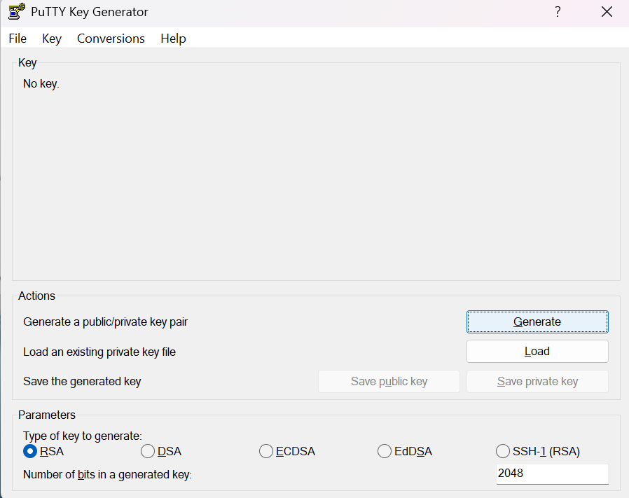
- While the key is being generated, keep moving the mouse over the blank area until the process is complete.
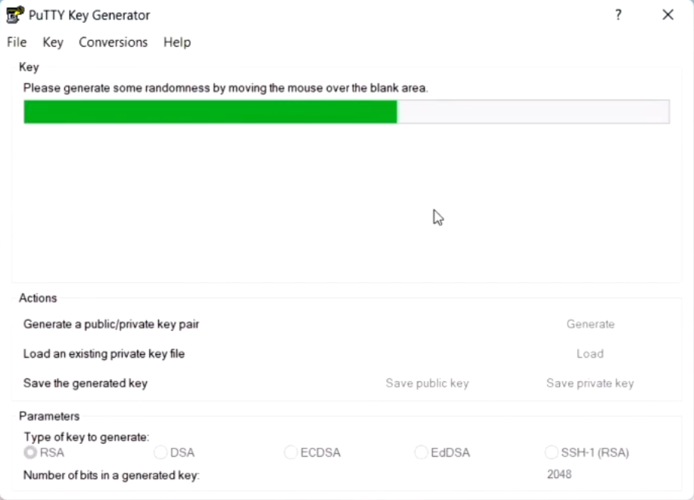
- Save both the public and private keys.
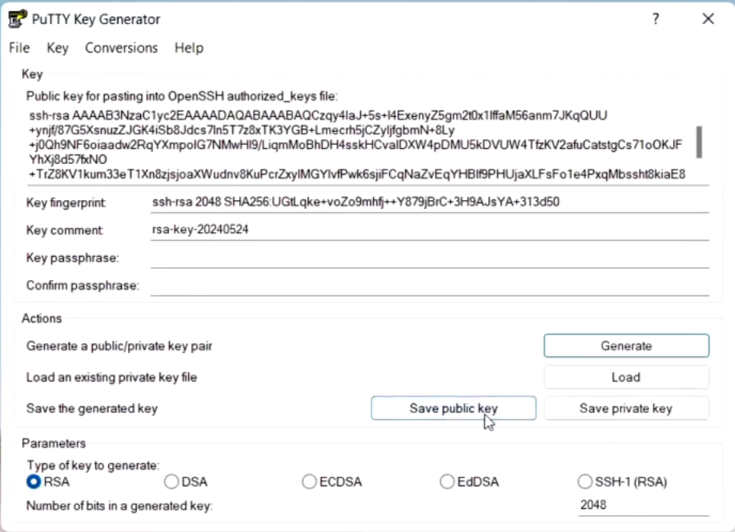
- Open PuTTY, follow the instructions in the picture, and browse to your private key file.
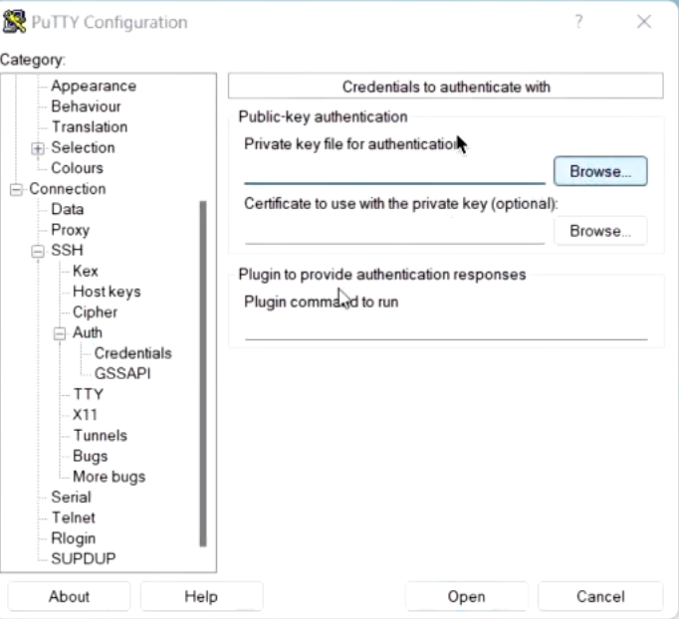
- Send your public key to your professor.
- After that, use the following command to connect to the CU-AIM server: ssh naruemonp@161.200.107.77 -i /path/to/your/private_key

Cyberduck settings

- Install Cyberduck.
- Open Cyberduck and click the "+" button below. Then follow the instructions in the picture and browse to the location of your SSH private key.
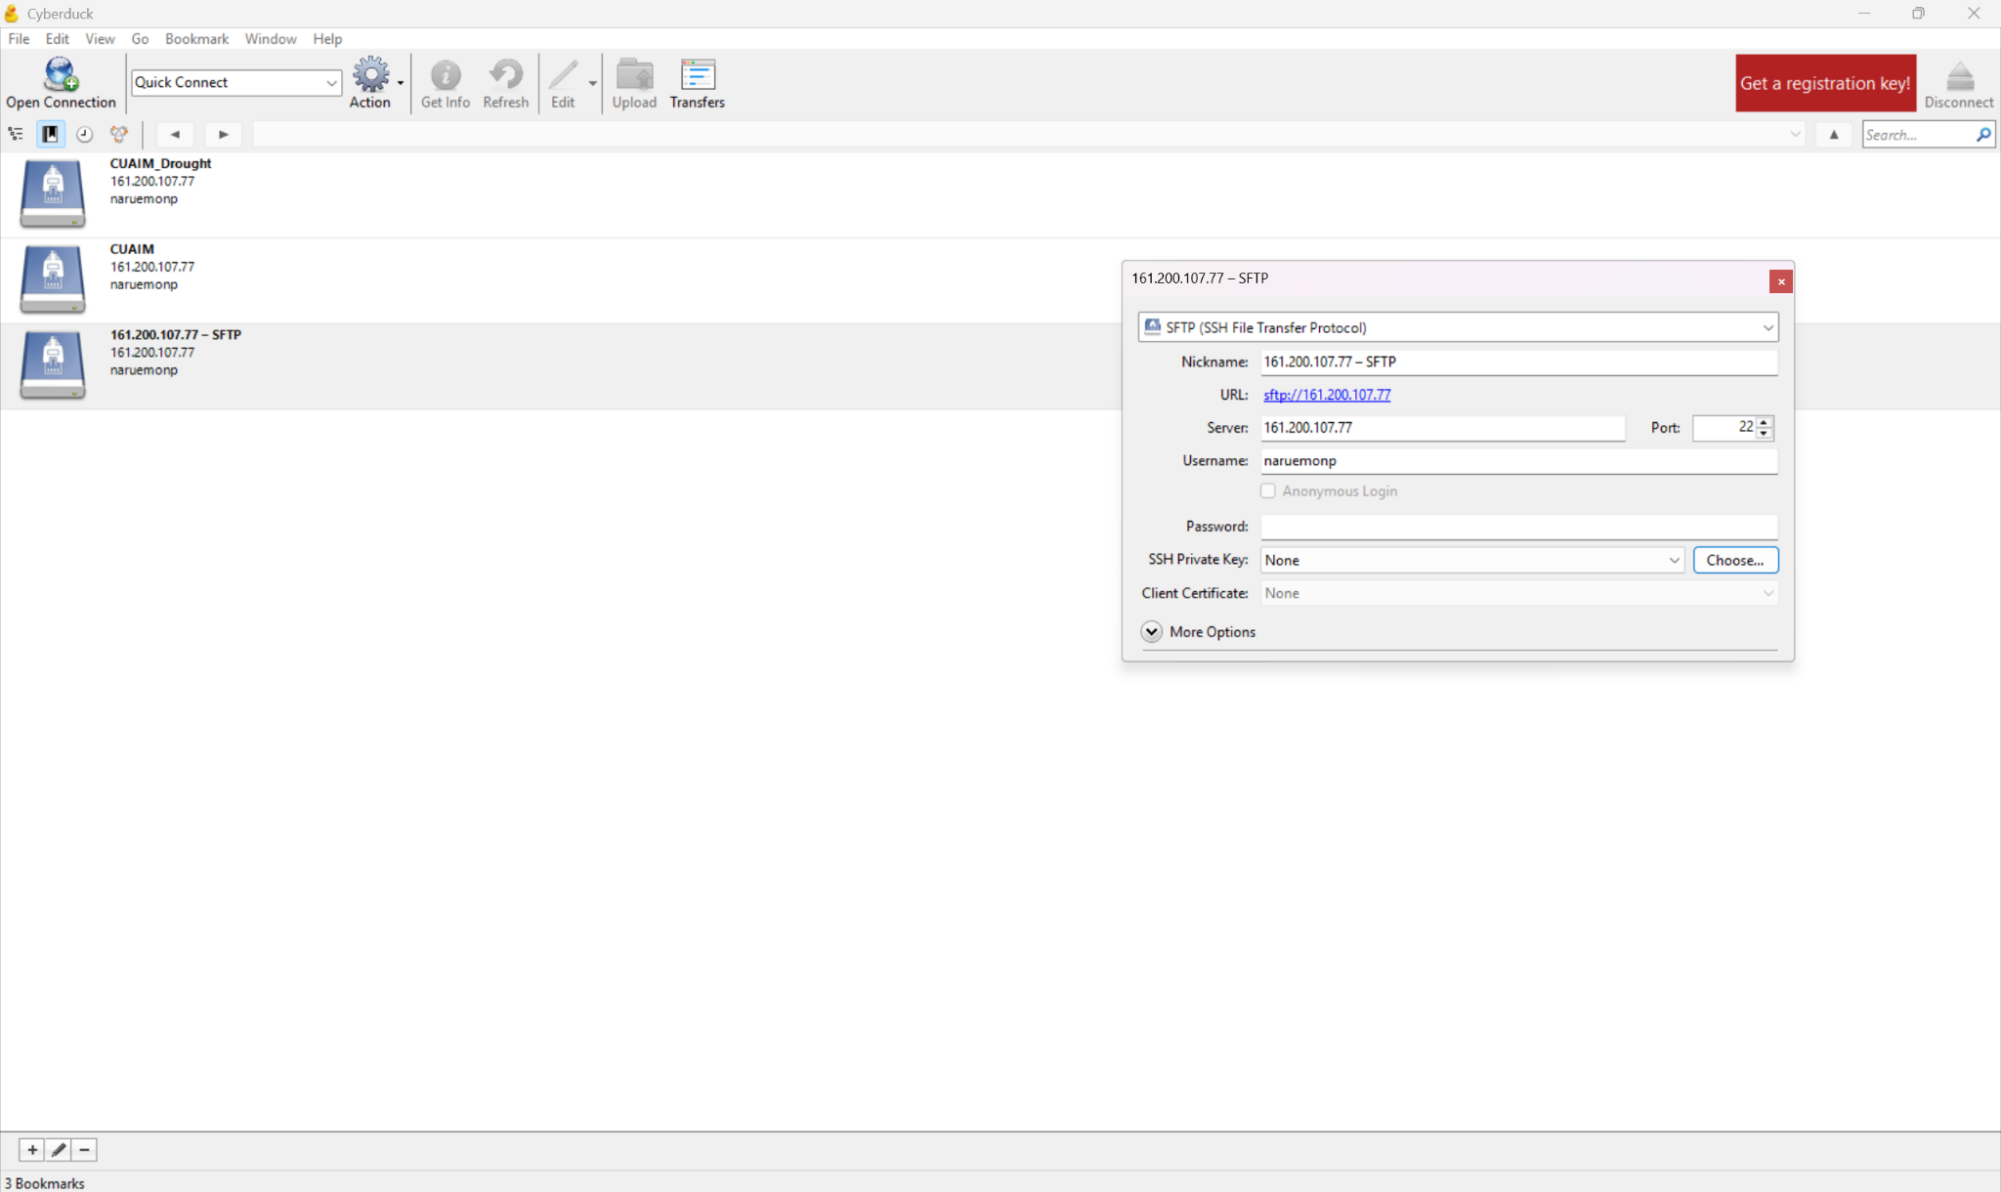
- Make sure that the current path is correct. It should not be /data/home; it should be /data/project/naruemonp.
- You can now drag and drop files, download files, and perform other file-management tasks.
- For file operations involving multiple files at once, consider using the command line instead of Cyberduck.

Using VS Code in CU-AIM
The current version of VS Code does not support the CU-AIM server. You need to downgrade to a compatible version.

Installing an old version (portable version)
- Download: https://update.code.visualstudio.com/1.85.2/win32-x64-archive/stable
- Extract the files to "C:\VsCode1.85", then create a folder named "data" inside it.
- Run "code.exe" inside the folder to start this older version.
- Make sure that automatic updates are disabled: https://code.visualstudio.com/updates/v1_85
- This version cannot use newer versions of extensions, such as Copilot.
- 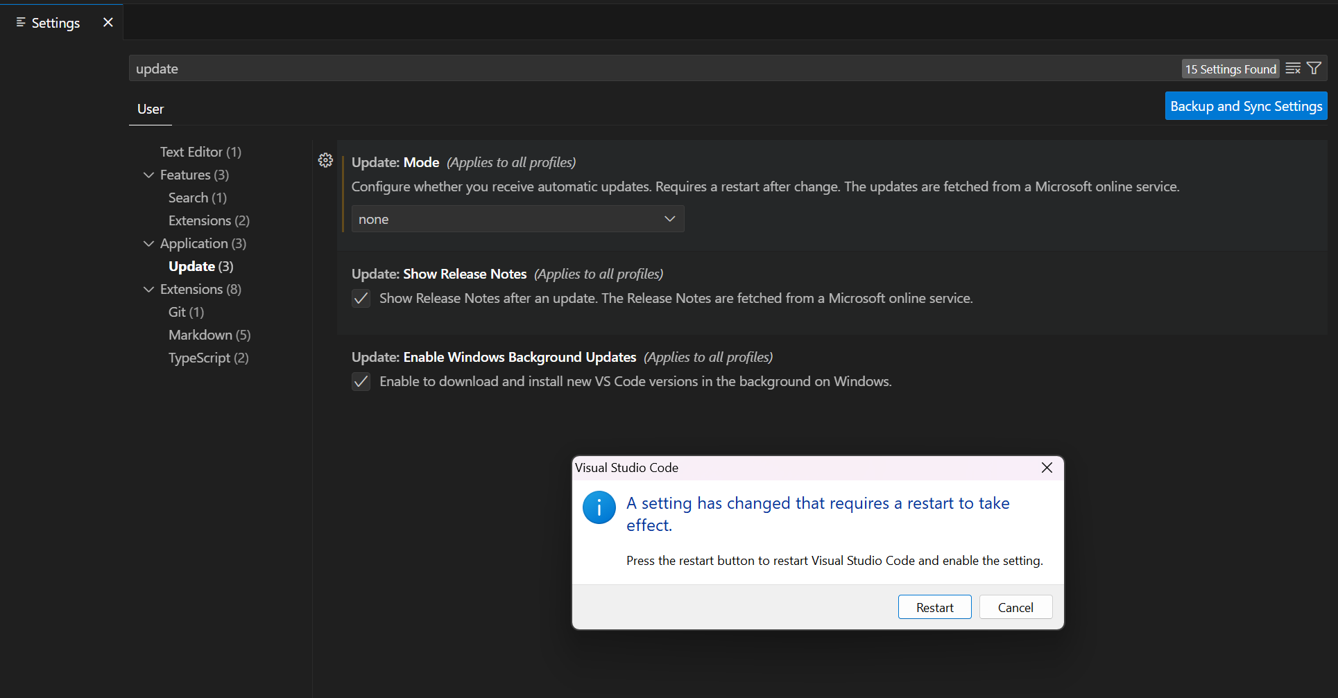

Remote coding on the SSH server with VS Code
Step-by-step:
1. Open VS Code.
2. Install the Remote - SSH extension.
3. Press Ctrl + Shift + P, then choose Remote-SSH: Open SSH Configuration File.
4. Add this to the config:
Host cuaim
HostName 161.200.107.77
User naruemonp
IdentityFile /path/to/your/private_key
5. Press Ctrl + Shift + P, choose Remote-SSH: Connect to Host, choose cuaim, and select Linux.

Using a GPU in VS Code
Copy and paste the following commands:
srun -p interactive-gpu -c2 --mem=8G --qos=interactive-gpu --gpus=1 --pty bash # You can select another GPU if needed.
conda activate drought_env_110625 # Your environment
jupyter notebook --ip=0.0.0.0 --port=8888 --no-browser
Look at the terminal and copy the first link after the line "Jupyter Server... running at".
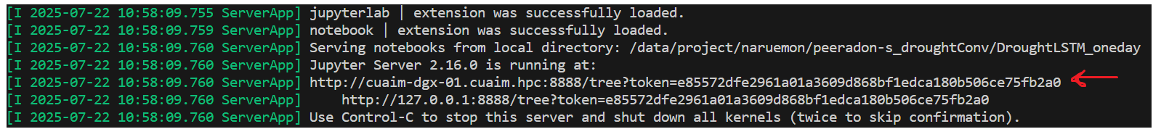
After that, select a kernel, then choose "Select Another Kernel" -> "Existing Jupyter Server..." -> paste the link -> select the button that appears.
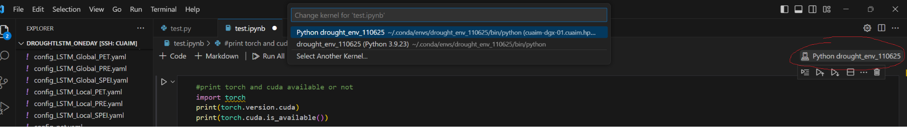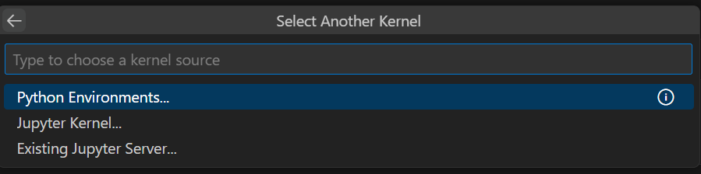
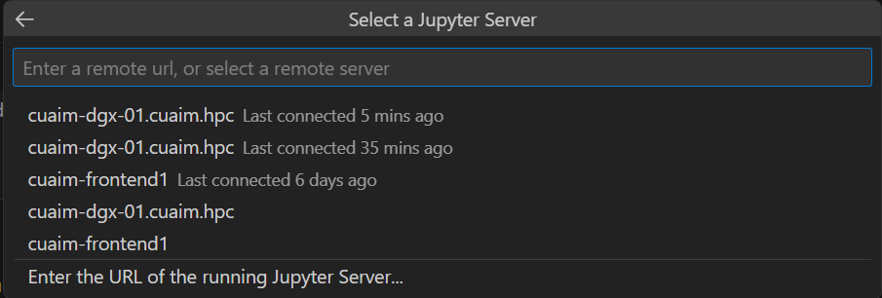

Using Singularity with VS Code and Slurm for interactive use
It appears that the problem is that glibc is too old because the host server has not been updated. To work around this problem, use a Singularity container and run your job inside it. This tutorial shows you how to set up your job so that you can run an .ipynb file in VS Code as you would on your local server.
- Create a .sif image with the following command, or use an existing container image: singularity pull <singularity_name>.sif docker://<pull_url>
- Set up the Bash script as shown in the example. You can adjust it based on your desired QoS, .sif location, environment name, and other requirements.
- You should also check whether the available image in /data/container_image on CU-AIM is too old for your needs. If it is, pull an updated image yourself.
- After that, submit the job with sbatch vscode_jupyter_job.sh.
- Then inspect the vscode-jupyter-<job id>.err file. You should see something like this:
[I 2025-07-23 13:04:57.843 ServerApp] Jupyter Server 2.16.0 is running at:
[I 2025-07-23 13:04:57.843 ServerApp] http://hostname:8888/tree?token=d65e97eaa83573335bd01f47cbc04d4eb92b97a357a153bd
[I 2025-07-23 13:04:57.843 ServerApp] http://127.0.0.1:8888/tree?token=d65e97eaa83573335bd01f47cbc04d4eb92b97a357a153bd
You need to copy the text after "token=".
- After that, run the following command. If it does not work, try running it in a local Command Prompt as well: ssh -i C:/Users/peera/Desktop/Key/privateKey_openssh.ppk -N -L 8889:cuaim-dgx-01:8888 naruemonp@161.200.107.77
- Then follow the instructions for using a GPU in VS Code above, but paste http://localhost:8889/?token=<copy_token> as the Jupyter server URL.
#!/bin/bash
#SBATCH --job-name=vscode-jupyter
#SBATCH --output=vscode-jupyter-%j.out
#SBATCH --error=vscode-jupyter-%j.err
#SBATCH --partition=gpu
#SBATCH --qos=gpu40g
#SBATCH --gres=gpu:7g.40gb:1
#SBATCH --ntasks-per-node=1
#SBATCH --cpus-per-task=16
#SBATCH --mem=64G
#SBATCH --time=8-00:00:00
#SBATCH --mail-type=BEGIN,END,FAIL
#SBATCH --mail-user=captainglueman@gmail.com

# Get the name of the assigned compute node using the 'hostname' command
# This is the correct way to do it.
NODE_NAME=$(hostname)

# The following line is useful for debugging and getting the hostname for your tunnel
# It will print the hostname to the output file (vscode-jupyter-JOBID.out)
echo "Jupyter is running on node: $NODE_NAME"

# Load the Singularity module (if required by your cluster)
# Note: You are loading CUDA and Anaconda3 outside the container.
# This might not be necessary if your container already has them.
# Loading modules inside a Singularity container can be tricky.
# Make sure your container is self-sufficient.
module load CUDA
module load Anaconda3
eval "$(conda shell.bash hook)"
source activate kan_mammote

# Start the Jupyter server inside the Singularity container
# The --nv flag is crucial for GPU access
singularity exec --nv \
--bind /data/project/naruemon:/data/project/naruemon \
/data/container_image/pytorch-22.03-py3.sif \
jupyter notebook --no-browser --port=8888 --ip=0.0.0.0 --allow-root --notebook-dir=/data/project/naruemon

Exploring the server (naruemonp)

Checking resources and QoS
- check_qos
To check the resources available for each QoS, use this command to allocate the resources you want to use with sbatch or srun.
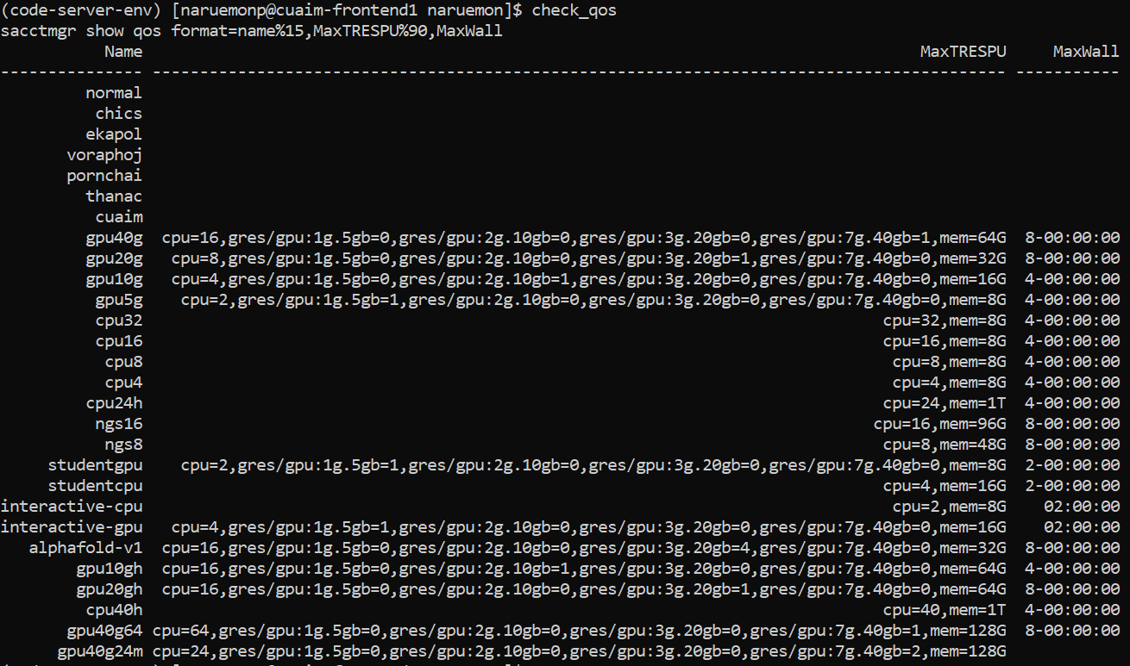
- check_group
To check the available QoS options for each user, run the command below. Our username is naruemonp. You can see that we have cpu40h, gpu10gh, gpu20gh, gpu40g, and gpu40g24m+ (when using gpu40g24m+ with sbatch, you only need to type gpu40g24m).
- sacctmgr show assoc user=<username> format=account,user%15,qos%50,defaultqos%20
Check the resources for that username.
- sinfo -o "%.15R %.8D %.10m %.5c %7z %60G %N"
Check the available resources on each node. This is not an essential command; it only checks the resources available on each node:
- scontrol show node <node-name>
Check the currently available resources on the specified node. This command is important because, even if you specify the correct resource and QoS, your job may not run if the current node does not have the required GRES.

Checking the queue
- squeue
Check the current queue.
- squeue -o "%.18i %.9P %.8j %.8u %.8T %.10M %.9l %.6D %R %b"
View the global queue for the CU-AIM server.
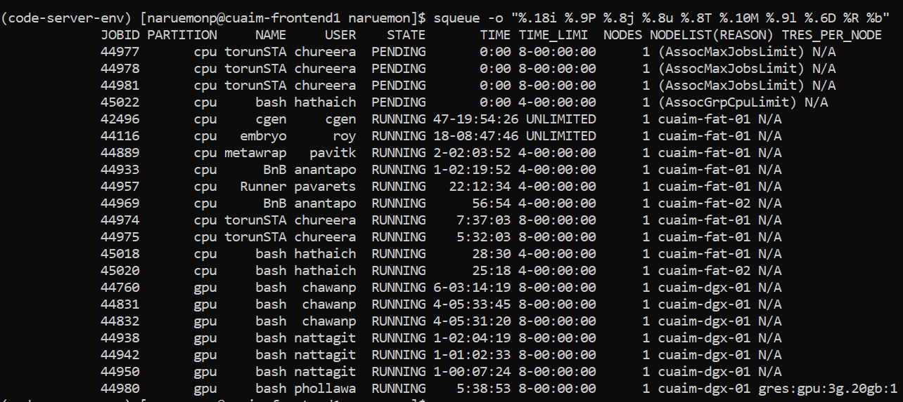
- squeue -u <username>
Check the queue in our lab. You can ask a senior member to cancel a job if you urgently need that resource.

- sacct -j <job_id> --format=JobID,JobName,State,ExitCode,Elapsed
Check the ID of an executed job.
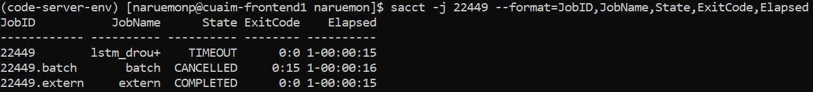
- sacct -u <username> --start=$(date -d '7 days ago' +%F) -o JobID,JobName,State,Elapsed,NodeList
Check jobs executed by that user during the past seven days.
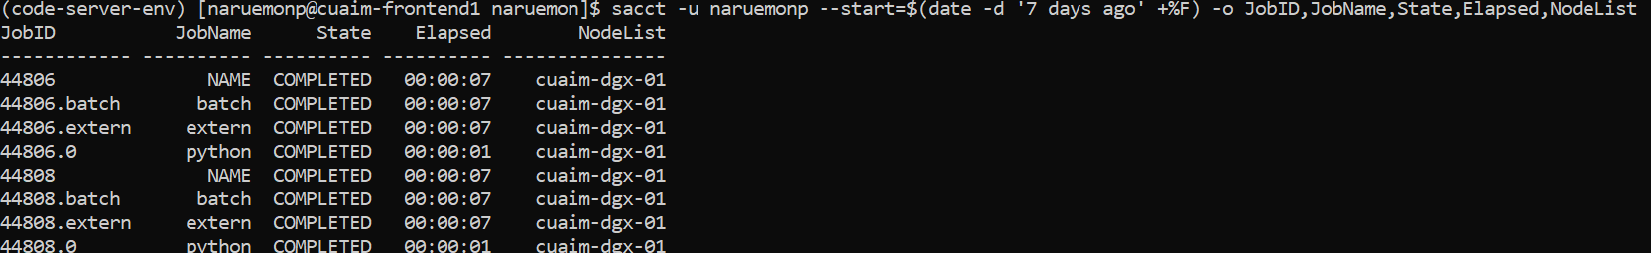

Submitting a job
- Normally, I use sbatch to submit a job by writing the .sh script in Notepad, saving it as a .sh file, and then uploading it to the appropriate folder with Cyberduck.
- sbatch <script_name>: to submit a batch script

Cancel a job.
- scancel -f <JOB_ID>

Useful Commands Summary
Command | Description
sbatch your_script.sh | Submit a job script
sed -i 's/\r$//' your_script.sh | Remove Windows carriage returns from script
squeue | View current job queue
squeue -u {user_name} -o "%i %T %C %P %j" | View the user-specific queue with additional details
squeue -o "%.18i %.9P %.8j %.8u %.8T %.10M %.9l %.6D %R %b" | Full queue details including GPU usage
module load Anaconda3 | Load Anaconda3 module
module avail | Check available modules on CU-AIM
module list | List your currently loaded modules
module unload {module_name} | Unload the given module
module purge | Unload all modules
module load CUDA | Load CUDA (required before environment creation)

QoS guide
- #!/bin/bash
- #SBATCH --job-name=clstm_single
- #SBATCH --output=logs/convlstm_global%j.out
- #SBATCH --error=logs/convlstm_global%j.err
- #SBATCH --partition=gpu
- #SBATCH --qos=gpu40g
- #SBATCH --gres=gpu:7g.40gb:1
- #SBATCH --mem=60G
- #SBATCH --time=2-00:00:00
- #SBATCH --mail-type=BEGIN,END,FAIL
- #SBATCH --mail-user={your_email}
- # Load required modules (adjust for your cluster)
- module purge
- module load Anaconda3
- module load CUDA
- eval "$(conda shell.bash hook)" # or your specific module

- You need to specify:
  - Partition
  - QoS name
  - Memory
  - Time
  - GRES
- If you want to use the same QoS for multiple jobs, divide the resources by the number of jobs. For example, if I want to use gpu40g for two jobs, I can divide the memory from 64G to 32G per job. Normally, I leave 1-2 GB unused to avoid a QOSMemoryExceeded error, so I would use 30G per job instead of 32G.
- CUDA on this server is version 11.8, and the GPU hardware supports up to version 12.2.

Sbatch command guide
- You can configure sbatch to run a .py script with: python {your.py}.
- You can configure sbatch to run an .ipynb file with papermill {your.ipynb}. Make sure that papermill is installed in your environment.
- You should create log and output files inside a logs folder. Make sure that you create this empty folder first.
- When specifying GPU or CPU resources, check the syntax carefully. Even an extra space or a misspelled option can cause a job to be cancelled from the queue without explaining what is wrong with the code.
- Running module purge before loading modules is good practice to avoid conflicts.
- Do not forget to do this if you want to use Anaconda and a GPU.
- module load Anaconda3
- module load CUDA

Server IP address

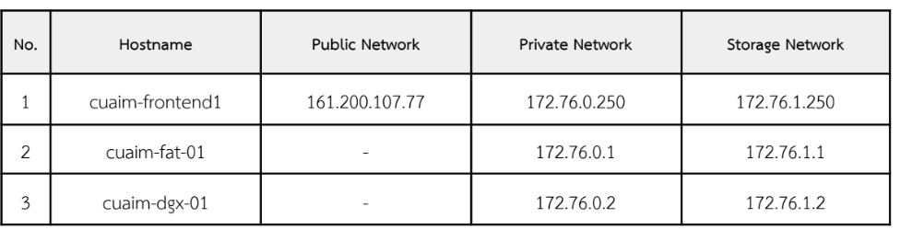

Upcoming Manual

Allocated, Allowed, and Available Resources

Working with Singularity for jobs that require a custom image

Checking job history

